



**E-Project Documentation**

**Teacher Name: SYEDA IMAMA ALI**

**APTECH COMPUTER EDUCATION**

**HYDERABAD-1 PAKISTAN**

**Issue Date: 5-DECEMBER-2023**

TABLE OF CONTENT

|  |  |  |
| --- | --- | --- |
| **S No** | **Contents** | **Page No** |
| 01 | Certificate | 3 |
| 02 | Acknowledgement | 4 |
| 03 | Project Report | 5 |
| 04 | Problem Definition | 6 |
| 05 | Customer Requirements Specification  (CRS) | 7 |
|  |  |  |
| 06 | System Requirement | 8 |
| 07 | Task Sheet | 10 |
| 08 | Project Plan | 11 |
| 09 | Checklist of work Progress | 12 |
| 10 | Screen Shots | 13 |
| 11 | Source Code | 24 |

CERTIFICATE

This is to certify that

**MUHAMMAD ZAQIB RIAZ**

Has successfully Designed

ZARA THERAPY CLINIC

Submitted by:

**Respected, Ma’aM SYEDA IMAMA ALI**

Date of Issue: 5-DECEMBER-2023

Authorized Signature**:Ma’am SYEDA IMAMA ALI**

ACKNOWLEDGEMENT

First and foremost, we would like to express our deep gratitude and most heartfelt thanks to almighty ALLAH for his blessings, for lightening up our heart with the torch of knowledge and for giving us the ability to complete this project.

We would like to thanks Aptech Worldwide and the team of E-Project for their generous support and clarifying the doubts regarding e-project. We would like to acknowledge the way of explanation which the team of e-project gave in e-project to make website and we are equally grateful to our teacher (Mam Syeda Imama) for giving us a moral support and guiding us different matters regarding project in all the time about the research and writing of this project.

We are greatly indebted to Aptech Worldwide, Mam Syeda Imama, Faculty Members and ACE Hyderabad, Pakistan for encouragement and incessant help.

PROJECT REPORT

**BY:**

**MUHAMMAD ZAQIB RIAZ, MUHAMMAD MADNI and**

**MUSTUFA ALI**

**Project Title: ZARA THERAPY CLINIC,**

**Members Name: MUHAMMAD ZAQIB RIAZ MUHAMMAD MADNI and MUSTUFA ALI**

**Batch Code: 2307E**

**Start Date: 5- DECEMBER-2023**

**End Date: 27-DECEMBER-2023**

**Course: ACCP (CPISM)**

**Teacher: Ma’am SYEDA IMAMA ALI**

**Center Manager: Sir SHOAIB AHMED**

**Center Academic Head: Sir ZUBAIR**

Submitted as

E Project Documentation

**PROBLEM DEFINITION**

At Zara Therapy Clinic, we help a person relieve stress, increase relaxation, improve circulation and gain relief from pain by manipulating the muscle and tissues in the body. They help rehabilitate injuries through touch and aid in the general wellness of a patient.

One of the most important marketing tasks one needs to complete is getting a website built for the respective services. Although a website by itself will not bring new clients to your practice, it will be very difficult to generate new clients online without a proper website strategy. Search engine optimization and advertisement can be used to expand your practice for long-term success once a website strategy is properly developed. Hence you need to develop a website for a therapist which will provide complete details about the services.

**Requirement Specification:**

The Web site is to be created based on the following requirements.

* The Home Page should be created making use of Sections with a suitable logo, the header section can be added which will show images of therapies/demo sessions.
* The site must contain the links to navigate through any category for the information.
* The site should display a menu which will contain the options for brief introduction about the various therapists available, contact details and any other information if required.
* There should be list of related products and services. The products may include essential oils, lotions and few helping machines and accessories.
* Various services should be categorized as per the technique/medical aid/beauty aids etc.
* Apart from all above there should be sections like
  + Gallery: High quality, premium images make the website aesthetically pleasing and provide a visual context for the products or services that the business trades in
  + Client testimonials/Reviews: Along with just text reviews, Video testimonials are also an effective way.
  + An About us page
  + Educational Information (About Therapies)
  + Offers and discounts

Should also be included in website

* There should be a “Contact Us” page which will have the Address of the stylist which should be displayed using Geo Location API (eg Google Maps) and the email address which when clicked will invoke the local mail client from where they can send an email.

PROJECT OBJECTIVE:

* The Objective of this program is to give a sample project to work on real life projects. These applications help you build a larger more robust application.
* The objective is not to teach you HTML/JavaScript/Dreamweaver/HTML5 but to provide you with a real life scenario and help you create basic applications using the tools.
* You can revise the chapters before you start with the project.
* This project is meant for students who have completed the module of ***Dreamweaver***. These programs should be done in the Lab sessions with assistance of the faculty if required.
* It is very essential that a student has a clear understanding of the subject. Students should go through the project and solve the assignments as per requirements given.
* Kindly get back to EProjects Team in case of any doubts regarding the application or its objectives.

**Hardware/ Software Requirements**

**Hardware**

* A minimum computer system that will help you access all the tools in the courses is a Pentium 166 or better
* 64 Megabytes of RAM or better

**Software *[Either or Combination as per Course/Sem]***

* **Notepad/HTML editor/CoffeeCup**
* **Angular / Angular JS / React / BootStrap**
* **Dreamweaver / Figma**
* **MS IE / Chrome / FireFox / Netscape /MS Edge**

**System Requirement:**

|  |  |  |
| --- | --- | --- |
| **SR.No** | **Items** | **Description** |
| 01 | Operating System | Window XP, Win7 or win8 |
| 02 | Main Processor | Minimum 2ghz or better |
| 03 | Ram (Memory) | Minimum 512mb or better |
| 04 | Web Browser | Google Chrome or Firefox (Latest) |
| 05 | Software | Notepad, HTML editor, Adobe Dreamweaver CS5.5 |

TASK SHEET

|  |  |  |  |  |  |
| --- | --- | --- | --- | --- | --- |
| **Project Ref. No:** | | **Date of Preparation of Activity Plan:** | | | |
| SR.  No | Task | Actual  Start  Date: | Actual  Day: | Team  Mates  Names: | Status: |
| 01 | Planning | 6-Dec-2023 | 1 | Zaqib,Madniand MUSTAF | YES |
| 02 | Data  Collection | 8-Dec-2023 | 1 | Zaqib,Madniand MUSTAF | YES |
| 03 | Designing  Home  Page | 9- Dec-2023 | 4 | Zaqib,Madniand MUSTAF | YES |
| 04 | Linking | 10- Dec-2023 | 9 | Zaqib,Madniand MUSTAF | YES |
| 05 | Check  Links | 13- Dec-2023 | 2 | Zaqib,Madniand MUSTAF | YES |
| 06 | Finalizing | 15- Dec-2023 | 3 | Zaqib,Madniand MUSTAF | YES |
| 07 | Testing | 17- Dec-2023 | 2 | Zaqib,Madniand MUSTAF | YES |
| 08 | Documentation | 20- Dec-2023 | 1 | Zaqib,Madniand MUSTAF | YES |
| 09 | Uploading | 26- Dec-2023 | 2 | Zaqib,Madni | YES |

PROJECT PLAN

* Website is able to execute quickly.
* The color scheme of the site looks attractive.
* The collection of data is authentic and taken by the most popular product websites.
* There is authentic information of facilities products with their specifications.
* Background is different to main page.
* The HOME is well prepared exactly for the same page as user clicks on the link..
* A visitor can also view the individual image of our every gallery.

**CHECK LIST OF WORK PROGRESS**

|  |  |  |
| --- | --- | --- |
| **SR:No** | **Aspect Tested** | **Remarks** |
| 01 | Data Collection | **yes** |
| 02 | Designing Home Page | **yes** |
| 05 | Linking The Pages | **yes** |
| 06 | Finalization | **Yes** |
| 08 | Tasting The Site | **Yes** |
| 09 | Documentation | **yes** |

**Screen shot of the Websites**

Home-page-1

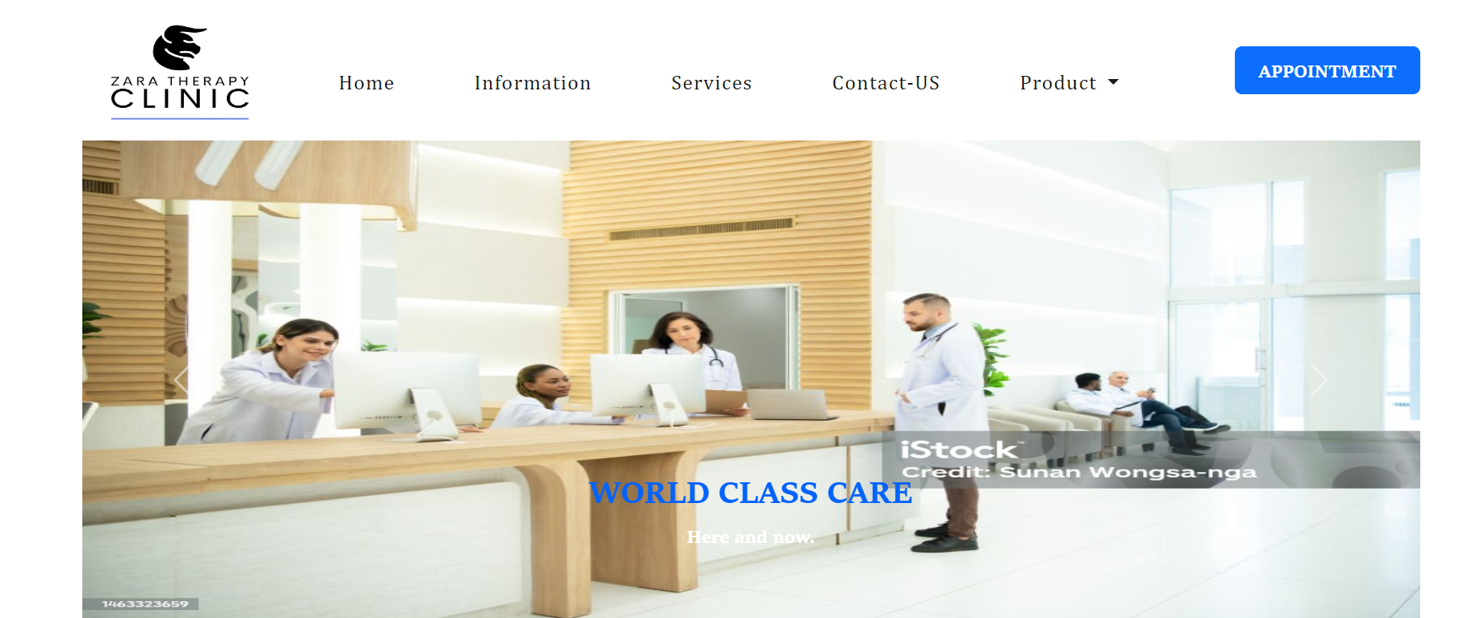

Home-page-2

Home-page-3

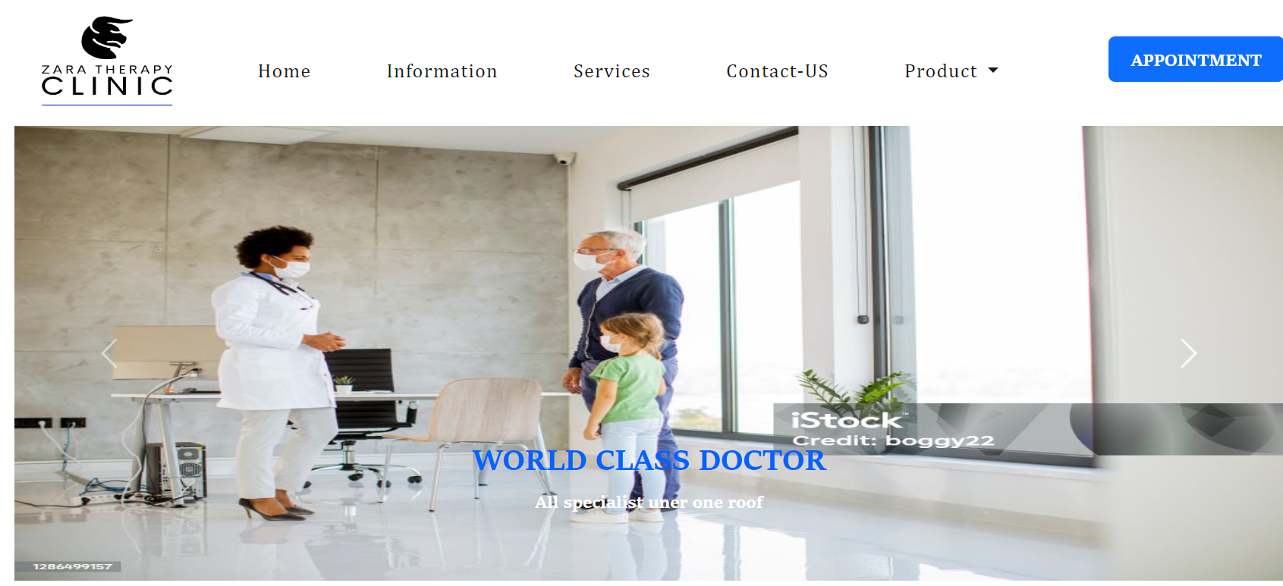

Home-page-4

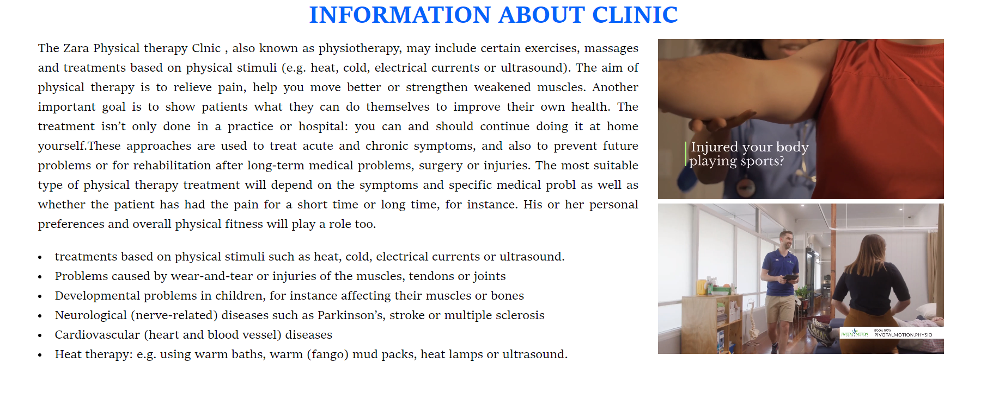

Home-page-5

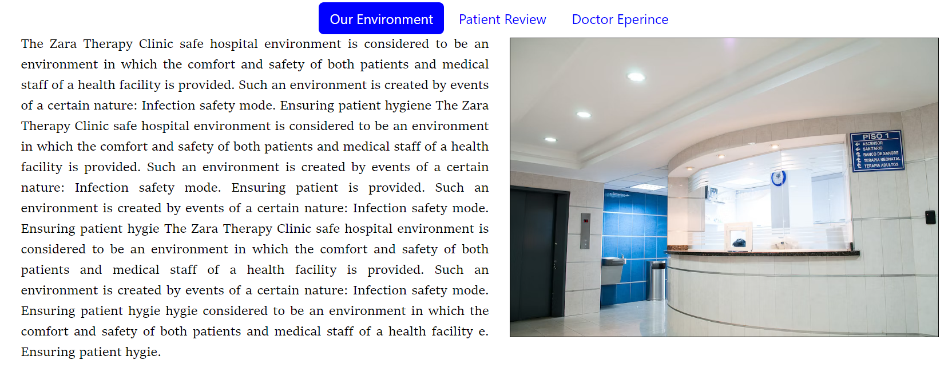

Home- Page-6

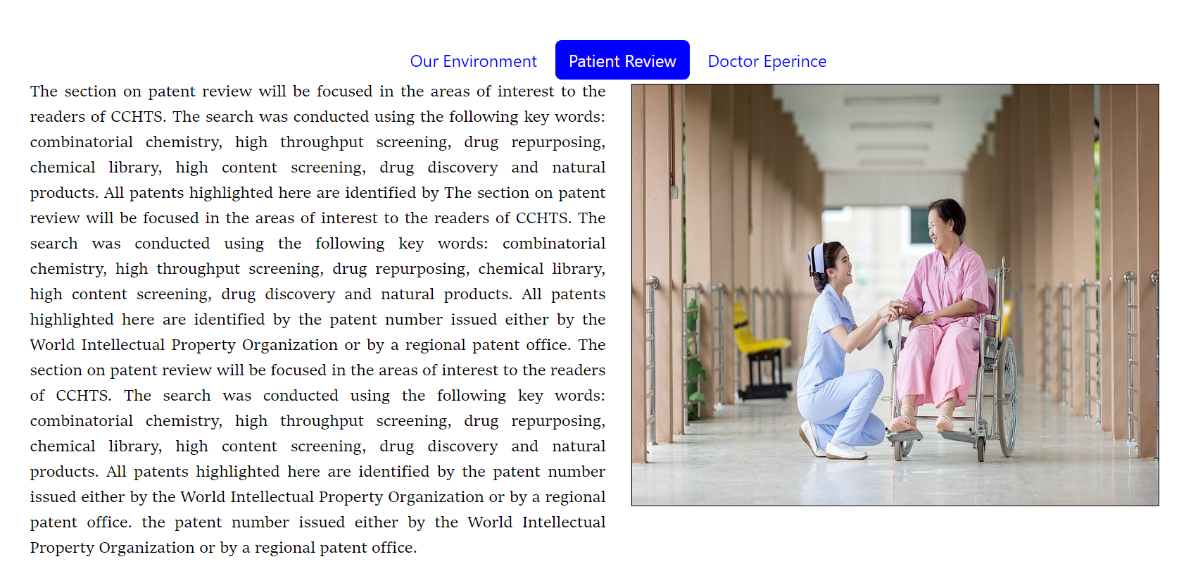

Home-page-7

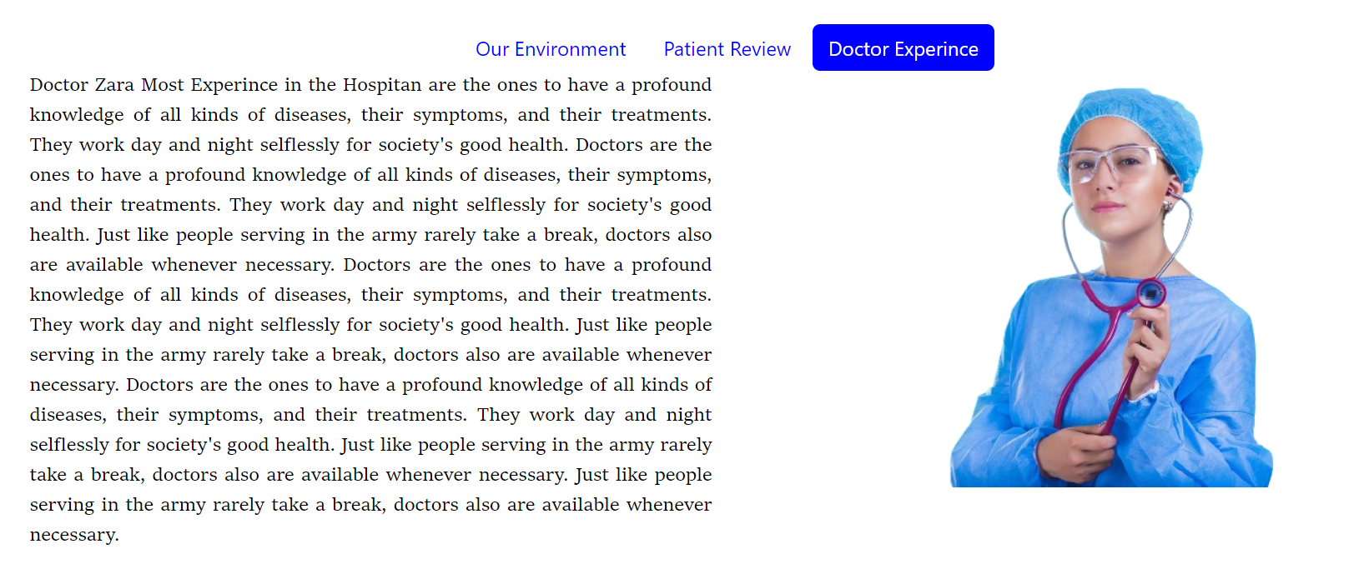

Home-page-8

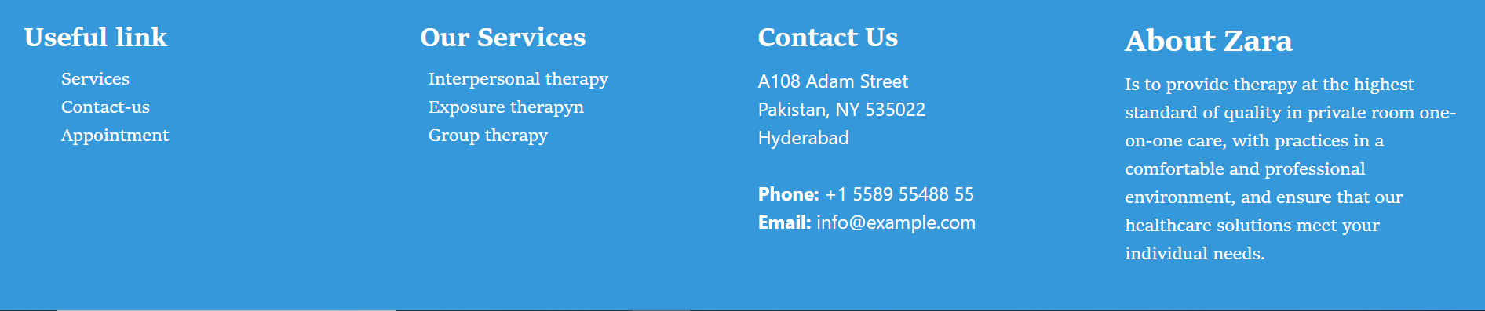

Product-page

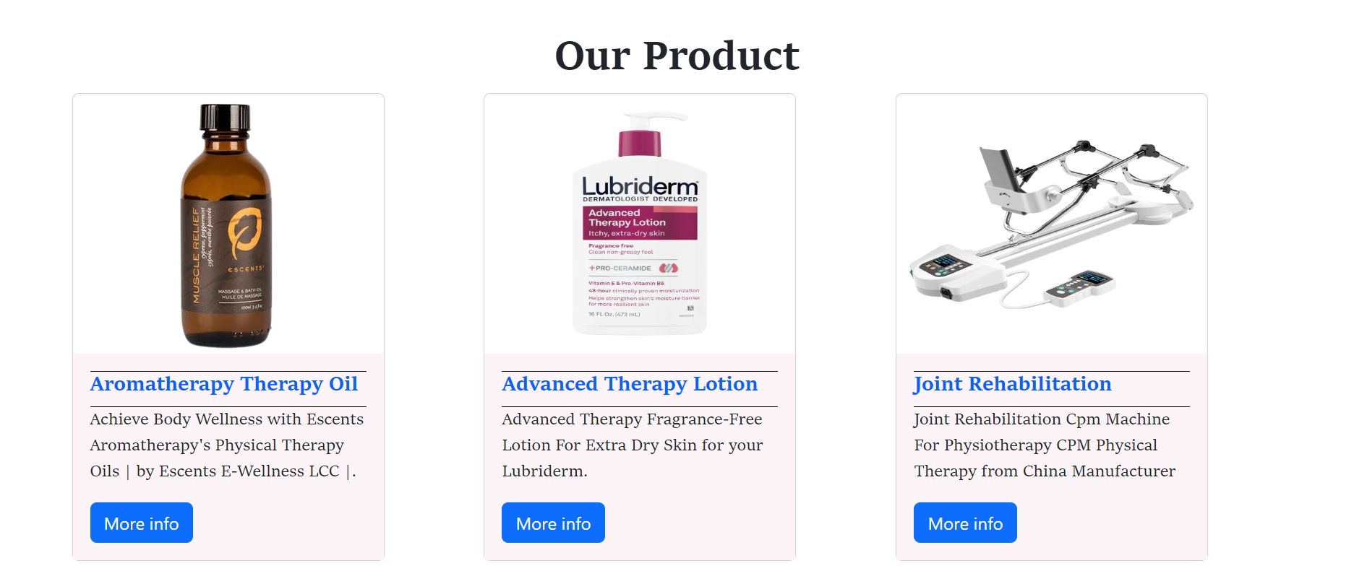

Zara Therapy Clinic on Mobile simulator

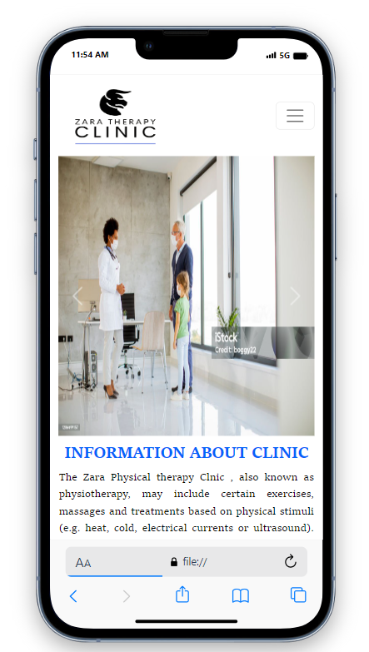

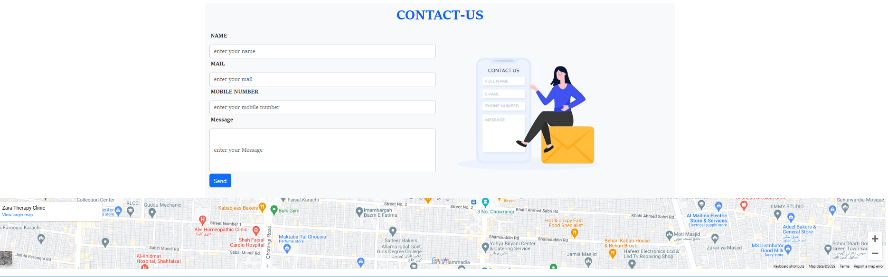

**Source of code**

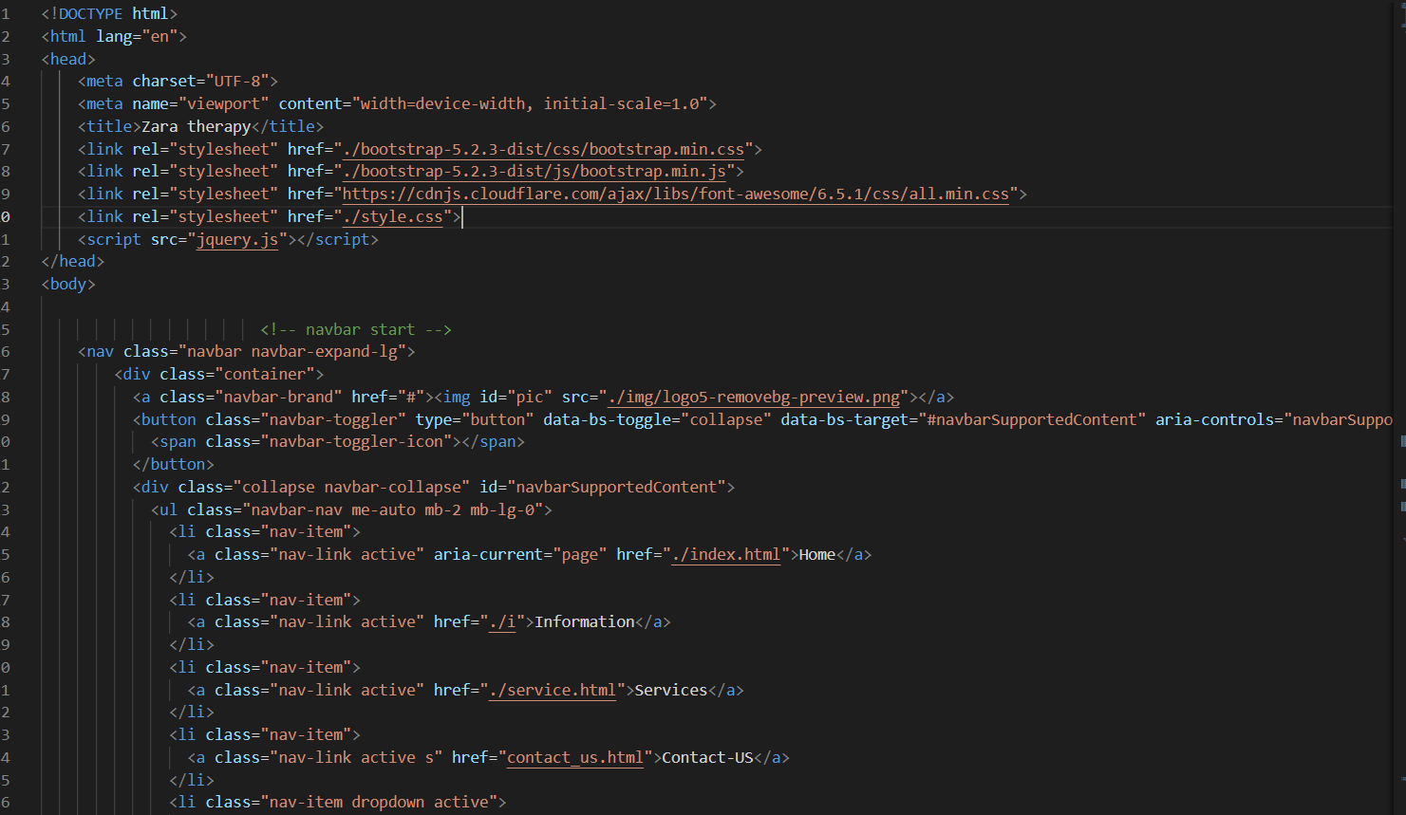

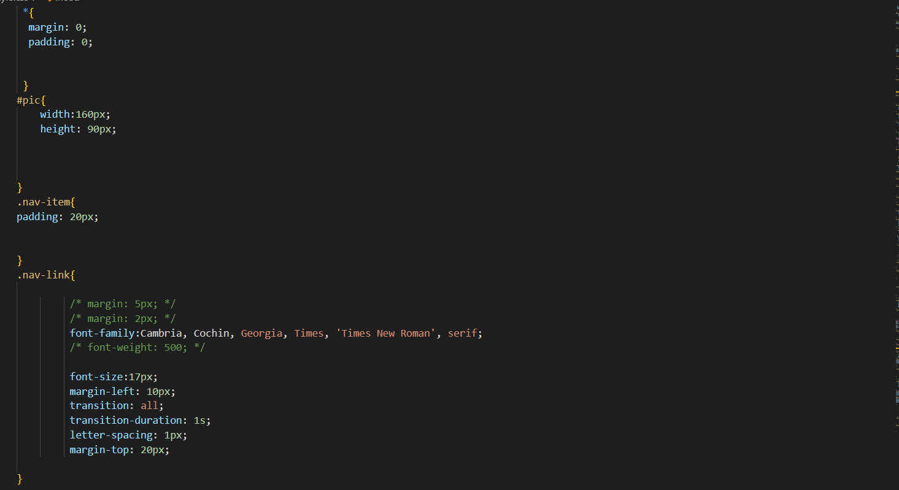

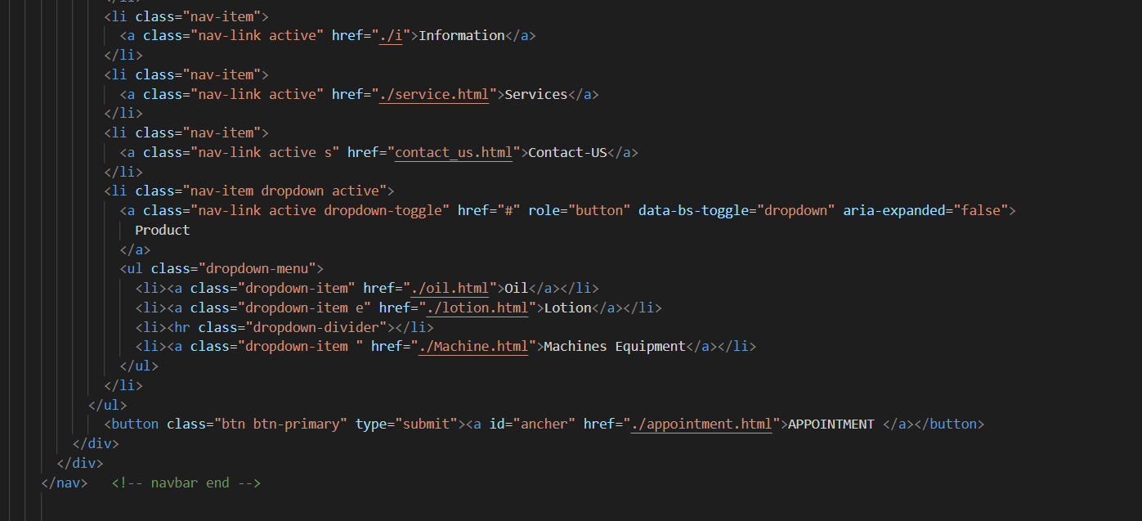

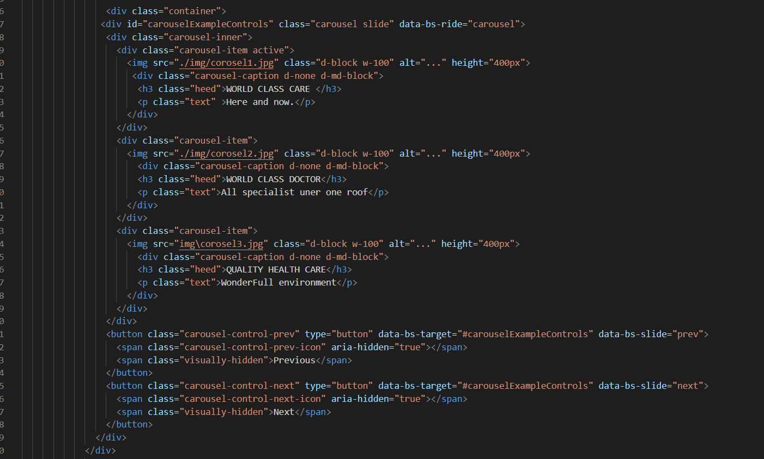

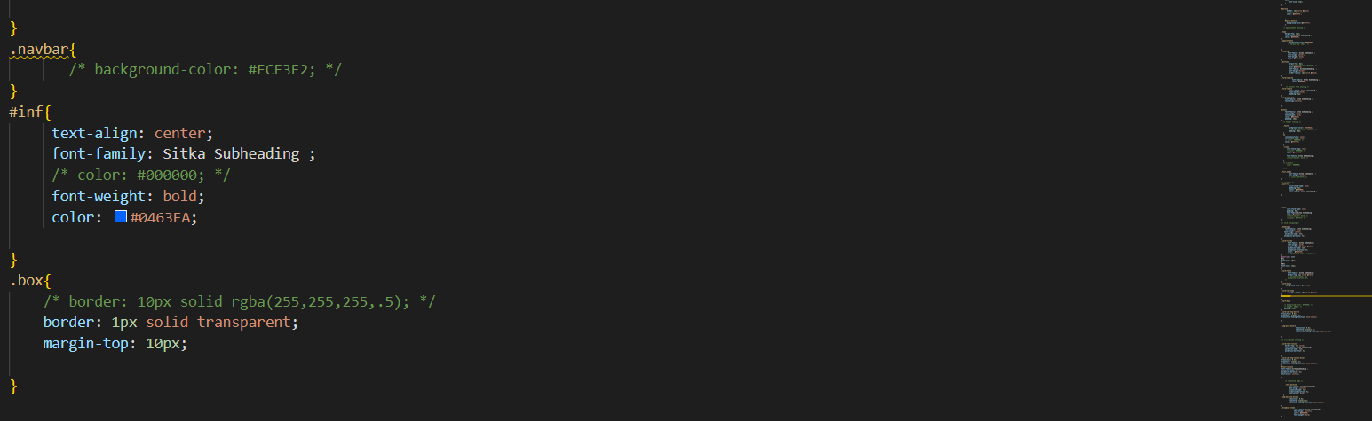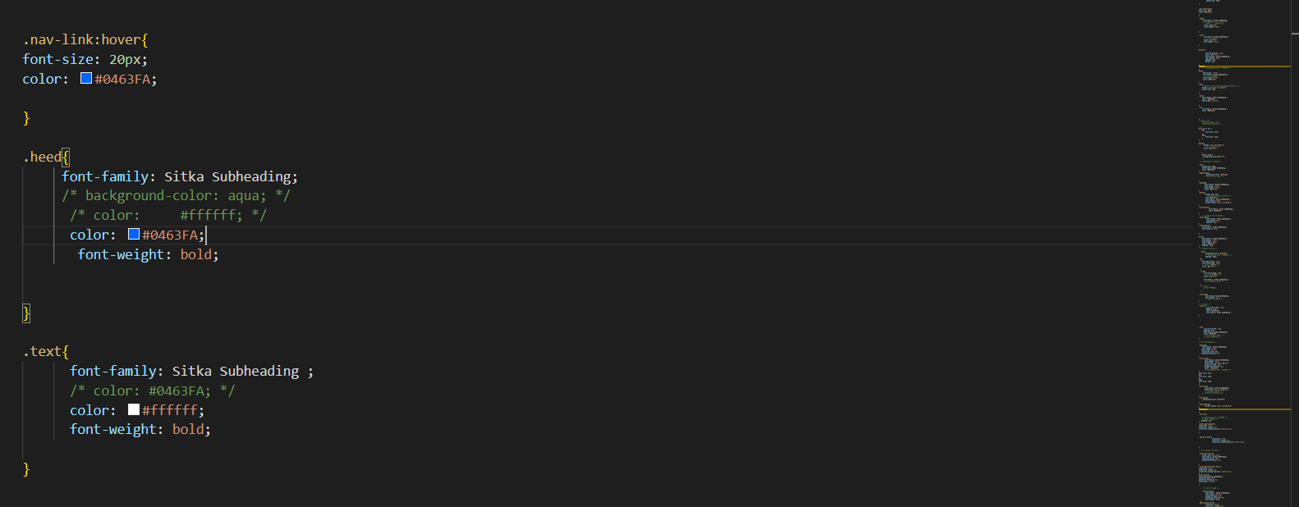

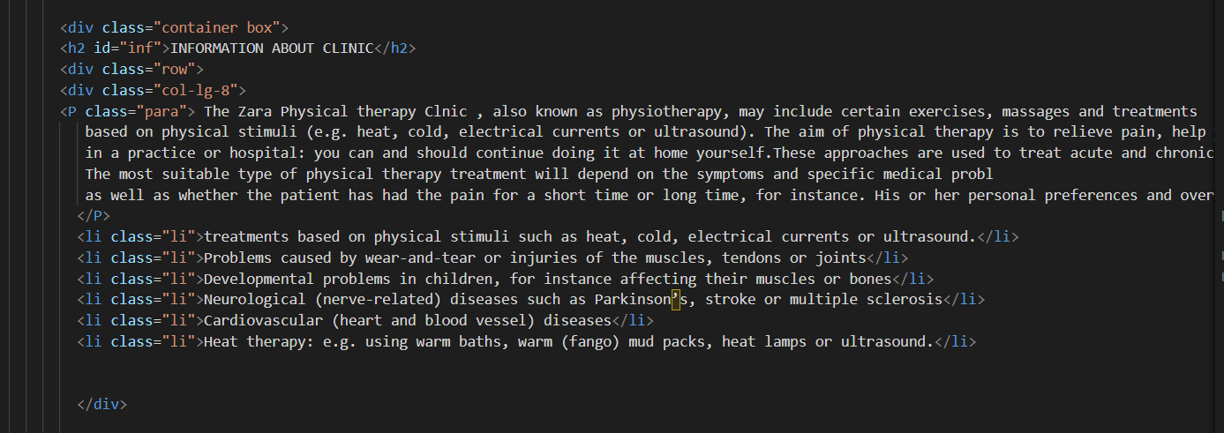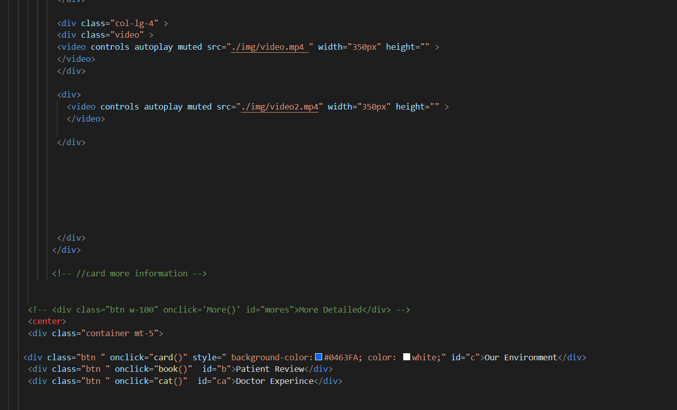

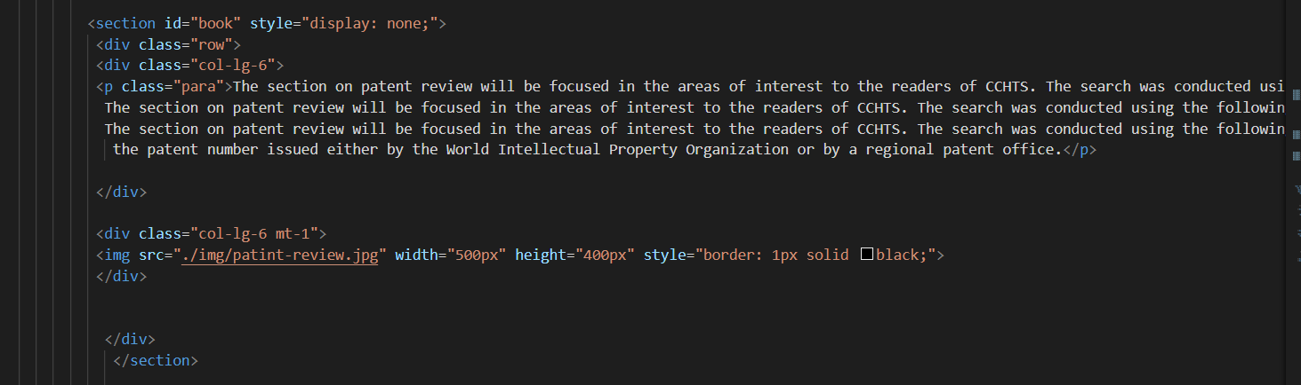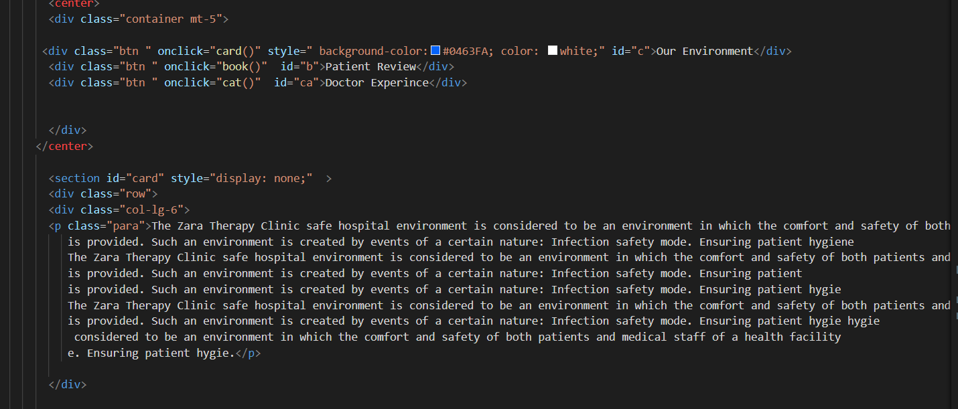

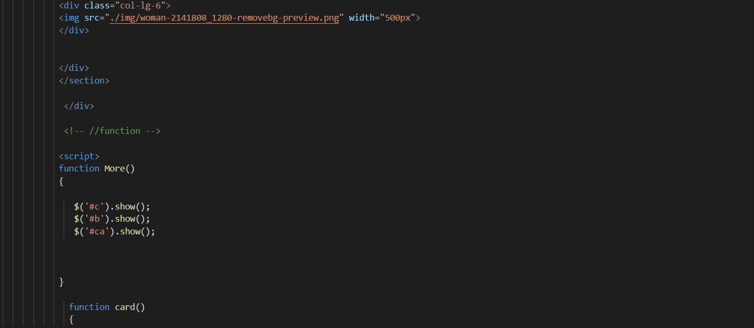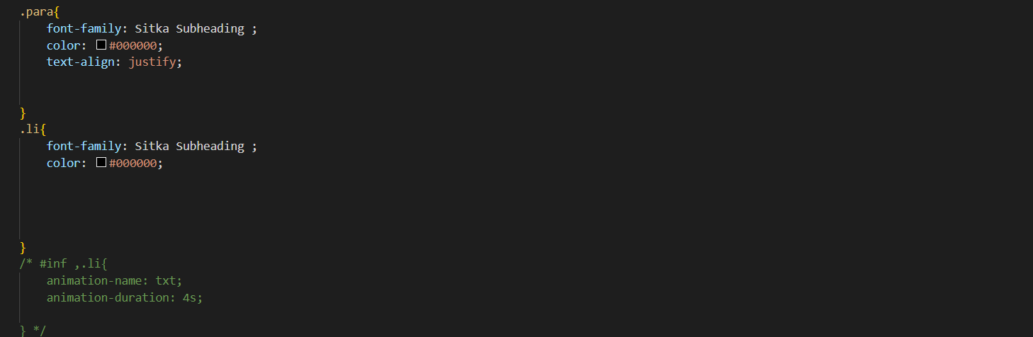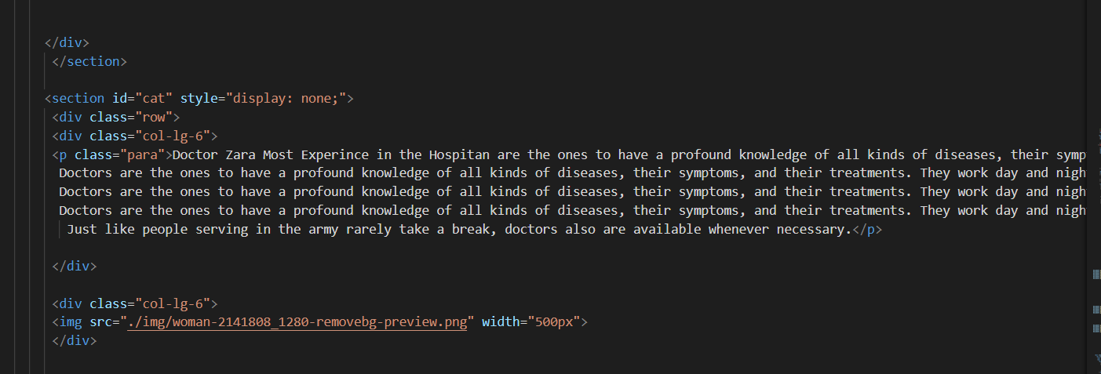

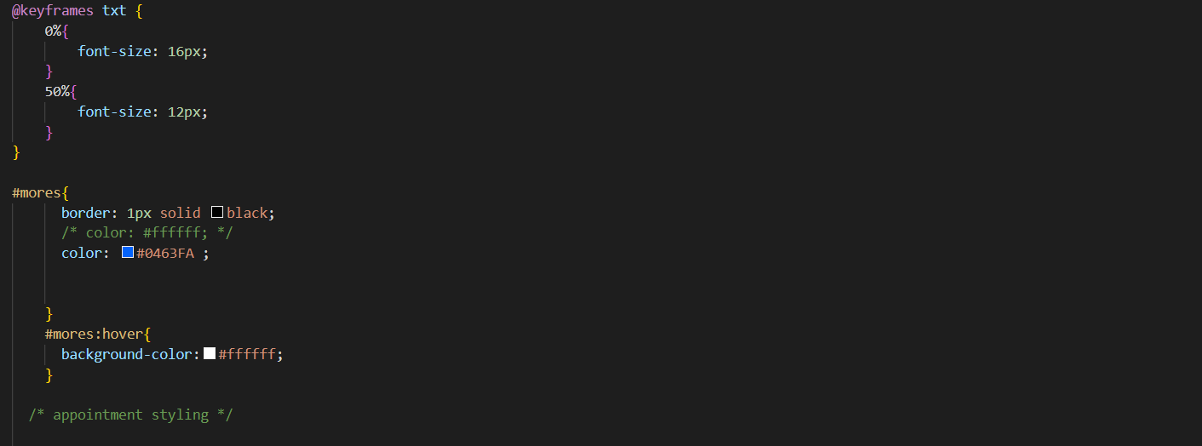

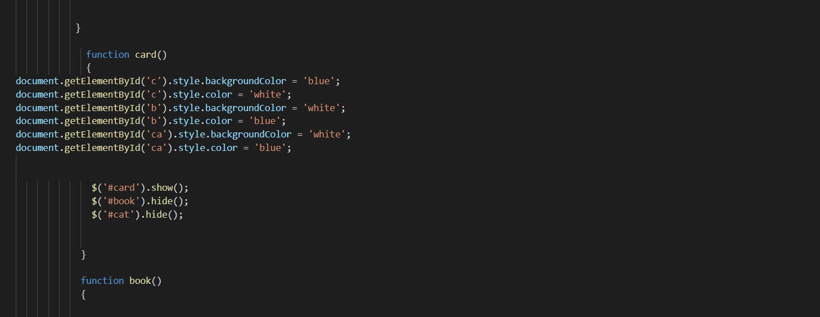

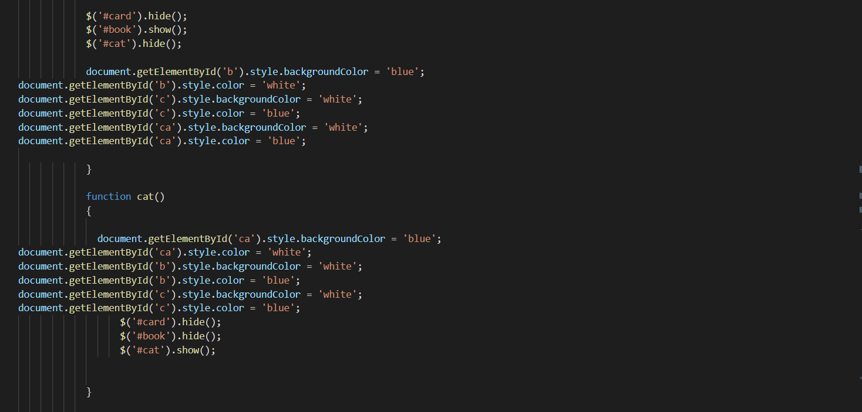

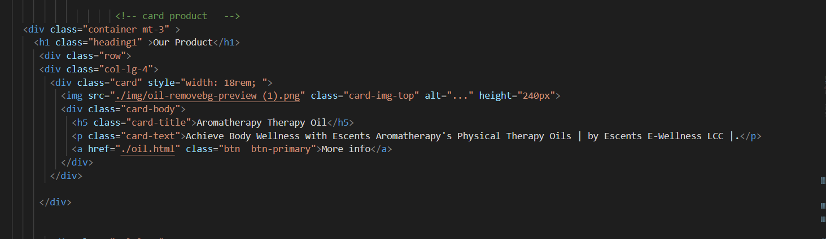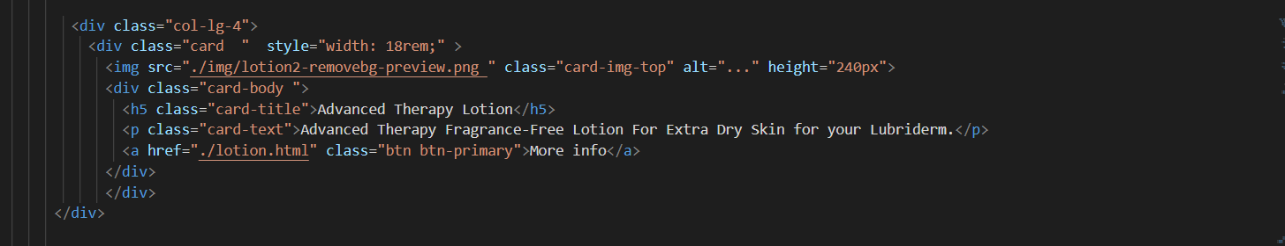

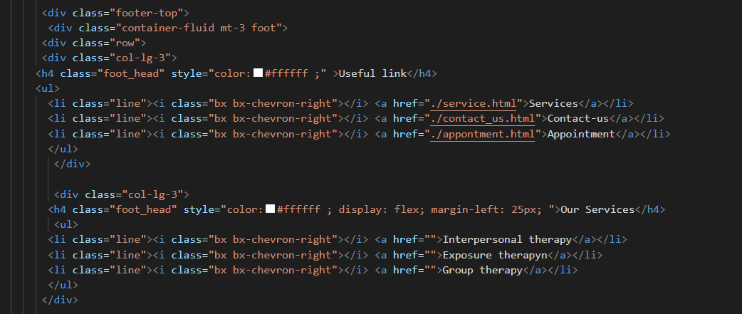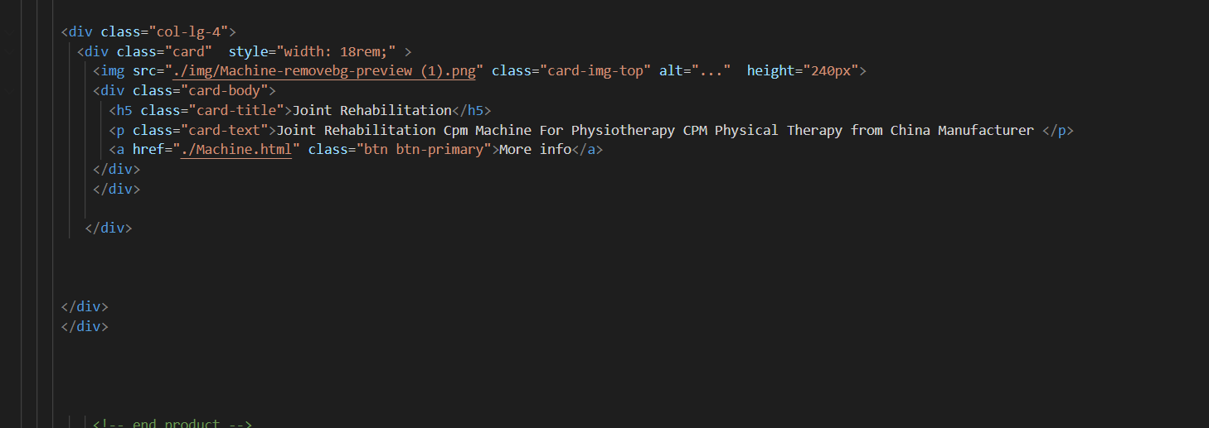

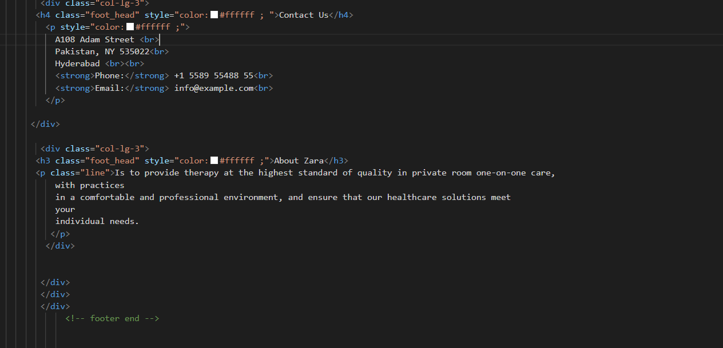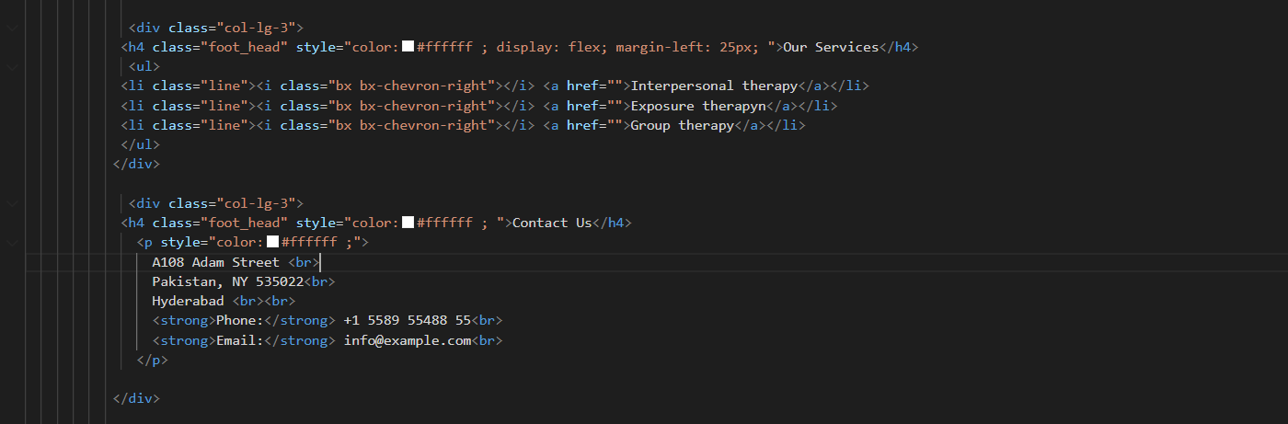

**Thank you**

**“EPROJECT TEAM”**

For wonderful opportunity

Work for the project

ZARA THERAPY CLINIC

